# TrackTraverse - Final Report

# Section 1:

# Application URL:

We have implemented the application frontend using React, complemented by a backend powered by Node.js. While we have achieved successful deployment of the frontend, regrettably, we encountered challenges in deploying the backend to showcase data.

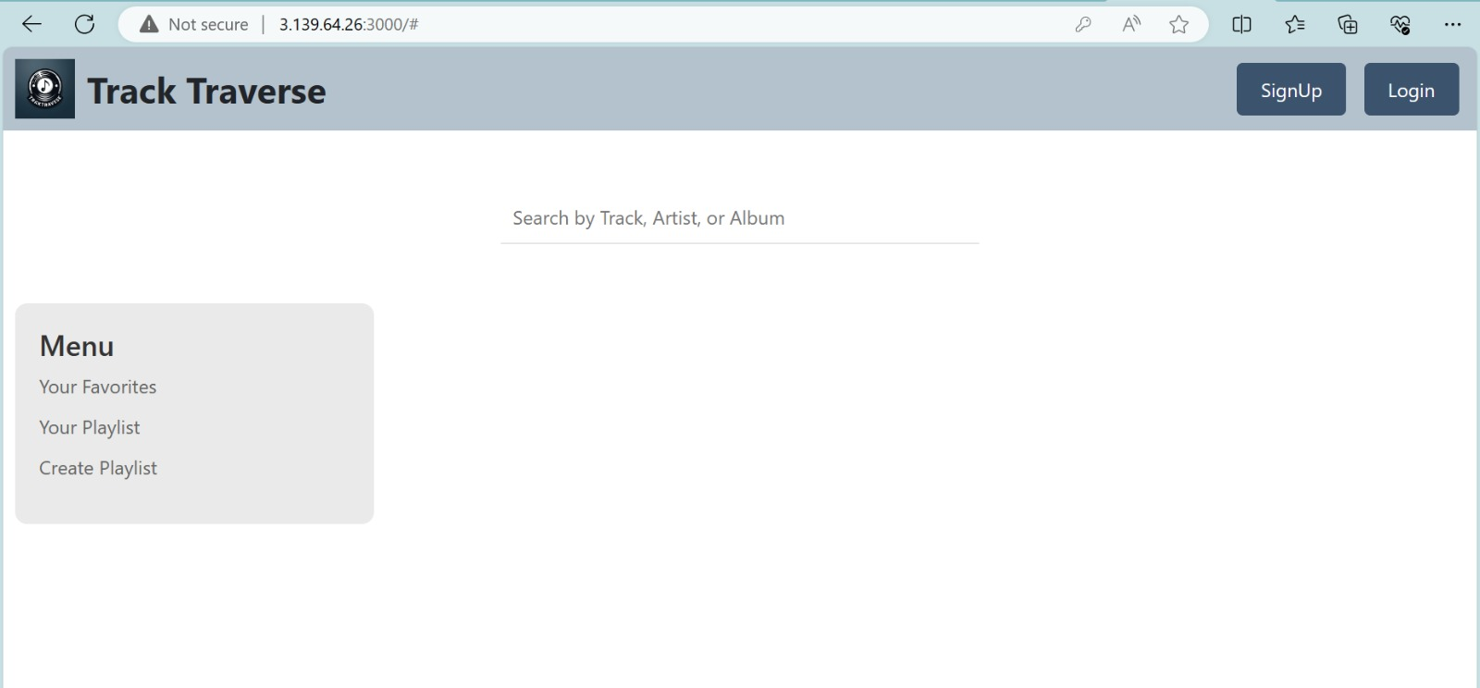

# Full GitHub URL:

We have uploaded the application source code with github at the following URL

**Frontend Repo :** [**https://github.com/AvishmitaMandal/Track-Traverse-FE**](https://github.com/AvishmitaMandal/Track-Traverse-FE)

**Backend Repo :** [**https://github.com/AvishmitaMandal/Track-Traverse-BE**](https://github.com/AvishmitaMandal/Track-Traverse-BE)

# Section 2:

# Purpose:

The purpose for building such an application is to address the need for a **visually appealing** and **user-friendly** music management system. With an emphasis on efficient organization and customization, our objective is to provide users with a platform that **simplifies the process of creating, organizing, and maintaining their favorite songs and playlists**.

One of our primary goals is to **combat disorganization** commonly found in music collections by offering intuitive tools for **cataloging tracks** and **creating playlists**. By prioritizing user experience, we aim to streamline CRUD (Create, Read, Update, Delete) operations, enabling users to **spend less time on administrative tasks** and more time enjoying their music.

Our notable feature, the **customizable playlist**, empowers users to curate their music according to their unique preferences, fostering a personalized listening experience. Through thoughtful design and efficient database management, TrackTraverse seeks to enhance the way users interact with their music libraries, ultimately providing a seamless and enjoyable music management solution. It is tailored to those who value a personalized and organized approach to managing their music libraries and playlists. By providing a user-friendly interface and addressing the specific needs of our target audience, **TrackTraverse aims to become a go-to solution for anyone seeking a seamless and enjoyable music management experience.**

# How did you build your project (tools/database technologies):

**Tools:**

**Version control : Github**

**Code Editor : VS Code**

**DB Client : MySQL Workbench**

**Deployment : ReactApp / vercel / phpMyAdmin**

**Front-End: React**

**Back-End: Node with express**

**Database: MySQL**

**Authentication: JSON web token JWT**

We have utilized **React** on the **frontend** to facilitate the creation of **dynamic and interactive user interfaces, enhancing user engagement**. This modern **JavaScript library empowers developers to build responsive interfaces that adapt seamlessly to user interactions**, resulting in a **visually appealing and intuitive platform**.

**Node.js with Express serves** as a flexible and efficient **backend** framework for managing server-side operations and routing, ensuring smooth communication between frontend and backend components.

In addition to the frontend and backend technologies, our project harnesses the power of **MySQL**, a widely adopted relational database management system. MySQL offers robust **data storage** and **management capabilities**, facilitating **efficient organization** and **retrieval of data**. Its scalability and reliability make it an ideal choice for handling the growing demands of our application.

To enhance **security and protect user data**, we implemented **JSON Web Token (JWT) for authentication**. JWT provides a secure method for verifying the identity of users, ensuring that only authorized individuals can access sensitive information and perform privileged actions within the application.

# Data:

We will use the dataset of [Top 10000 Songs on Spotify 1960-Now](https://www.kaggle.com/datasets/joebeachcapital/top-10000-spotify-songs-1960-now). It is a comprehensive collection featuring 10,000 of the most popular songs spanning the period from 1960 to the present day. The dataset is meticulously curated based on rankings from the ARIA (Australian et al. Association) and Billboard charts, providing a diverse representation of songs that have achieved significant commercial success and cultural impact. In managing the dataset, the integrity will be ensured by carefully reviewing each attribute. The **Null records in the attribute column will be removed** to streamline our analysis, we will concentrate on the **top 200 records**. This focused approach aims to improve the precision and relevance of the extracted information. We will not be doing any preprocessing on the Image URL as of now and try to build the application.

# Functionalities:

Our application boasts a robust set of features aimed at providing users with a comprehensive music management experience. At the forefront of our functionality is a robust authentication system, comprising dedicated login and signup pages. This ensures that user access remains secure and personalized.

A standout feature of our application is the ability for users to **create and customize playlists** to suit their individual preferences. Upon creating a playlist, users have the **flexibility to effortlessly add or remove songs as they see fit**. This level of control empowers users to curate their music collections with ease.To streamline the process of adding songs to playlists, we've incorporated a **user-friendly interface** with an **intuitive button feature directly on each song tile**. This allows users to seamlessly add their favorite tracks to playlists without navigating through multiple screens.

In addition to playlist management, our application offers **advanced search functionality**. Users can easily search for songs by name or artist, simplifying the process of discovering new music or finding specific tracks within their collection.

1. ***SignUp / Login :***



The user can sign up using their **email address** and **password,** post which they can use the same credentials which will be validated against the database with the **JWT token** for secure authentication and personalized experience.



If the user is not authenticated, it will **prompt the user to login** for them to use any of the options such as **viewing their favorites**, **playlists** or **creating new playlists**.

1. ***Search :***



The user can search for their favorite tracks using the t**rack name, album name** or the **artist name** all using a single search bar providing a simple user experience.

1. ***Pagination :***



We have introduced pagination where the user doesn’t have to scroll deep down through the page and can navigate about any page seamlessly.

1. ***Add to playlist :***



The **add-to-playlist** button is present on the music grid where the user can click and either insert that track into a pre-existing playlist from the **Select Playlist** section or can navigate over to the **Create Playlist** section to create a new playlist for the track.



The user can look at all of their playlists and the tracks present in those playlist in the **Your Playlist** section.

1. ***Delete playlists / tracks from the playlist :***



Users can also **delete playlists** if they feel like they are no longer required. There is an option to **remove tracks from the playlist** as well. They can do so by just clicking on the delete icon.

1. ***Add to favorites / Removing from favorites :***



Users can directly click on the **heart icon** to add tracks to favorites. They can view their favorite tracks from the **Your Favorite** section and further also **remove tracks** from the favorites list.

1. ***Create playlist***



Users can also create a new playlist by clicking on the **Create Playlist** option on the sidebar and enter the name of the new playlist and click on **Create**.

They will now be able to see their playlist on the **Your Playlist** section.

# Section 3:

# Issues :

1. Authentication:
   * Issue: Token verification problem due to the dynamic generation of the secret key on service boot-up.
   * Solution: Implemented a method to generate and securely store the secret key in a .env file for consistent token verification, enhancing security and eliminating the need for repeated logins.
2. Authentication Scope:
   * Issue: Determining which backend APIs necessitate user authentication.
   * Solution: Defined authentication requirements by studying similar products for reference. Identified APIs such as Login/Signup and accessing basic content like songs on the homescreen as non-authenticated.
3. UI Development:
   * Issue: Parent component CSS styles overriding child component styles.
   * Solution: Adjusted layout and applied alternative methods to prevent parent styles from interfering with child components, ensuring consistent and expected styling.
4. Database Optimization:
   * Issue: Over-normalized database schema leading to complex queries and redundant attributes.
   * Solution: Denormalized tables where appropriate, simplifying data retrieval through APIs. Removed redundant attributes and introduced new tables like playlists and favorites to align with the application's functional requirements and enhance performance.